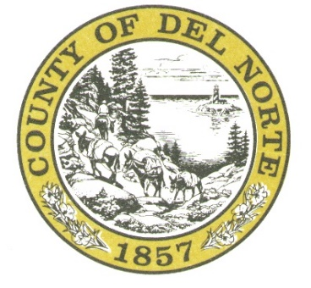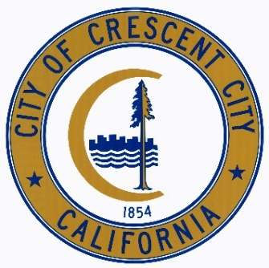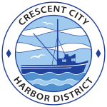

County of Del Norte
City of Crescent City
Crescent City Harbor District
Joint Meeting

Veterans Hall
810 H Street
Crescent City, CA 95531

June 11, 2024 5:00 P.M.
IF YOU REQUIRE AN ACCOMMODATION DUE TO DISABILITY under the Americans with Disability Act that does not allow you to participate remotely or provide written comment ahead of the meeting YOU MUST notify the Clerk of the Board at least 24 HOURS in advance of the meeting and a reasonable accommodation will be made.

- Call the meeting to order.
- Roll Call.
- Pledge of Allegiance.
- Public Comment.

- Discussion and possible action regarding the future of the Tri-Agency Economic Development Authority including:

  - Continuing the Tri-Agency Economic Development Authority

Discussion and possible action / direction to include the following items:
    - Joint Powers Agreement (JPA) and possible revisions
    - Member Agency contributions
    - Staffing / Work Plan
    - Existing litigation Expense Funding

Or

  - Terminate the Tri-Agency Economic Development Authority pursuant to Section 8.03 of the Joint Powers Agreement.
    - Discussion and possible action to split the costs of existing litigation, dissolution, and any other outstanding debts or liabilities of Tri-Agency and to negotiate a dissolution agreement amongst the member agencies.

ADJOURNMENT
Date Posted: 6/7/2024

